

**NOTIFICATION FORM OF AN ACCIDENT/INCIDENT OUTSIDE SCHOOL**

**To: Tiger Tots Preschool**

Child’s Name: _____________________________________________________

Class: ________________________________Date: _______________________

Please note that my child had an accident/was the subject of an incident/bruised themselves (delete as appropriate)

(Description) ______________________________________________________

_________________________________________________________________

_________________________________________________________________

Action to be taken by the school if any: __________________________________

_________________________________________________________________

Signature (Parent/Carer) _______________________________

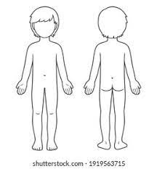Please mark with a X where child is hurt.

Tiger Tots Director Signature ________________ Date _______